Drafting in Los Angeles
Zvi Mowshowitz
Every draft has a few key decisions, and these decide who plays which colors and generally by extension who gets the better decks. This is a close examination of LA's top eight draft to look at such decisions, and how the cards often force players into decisions they don't want to make in Invasion draft. In his coverage of the Top 8 draft from PT:LA, Alex Shvartsman wrote:
Over the next several packs, players set into the following colors:
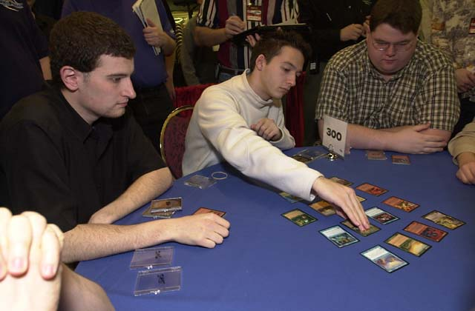
Creech: W/U
Gurney: B/R
Ekebom: B/U
Cornelissen: R/G
Pustilnik: U/W
Finkel: R/B
Klauser: G/W
Rose: B/R
It is highly unusual for so many players to use only two colors a person in Invasion. This did not last very long. Kyle Rose opened Rith the Awakener on the 8th pick. No one was in position to take it early and it went all the way to Cornelissen. Rose opened a second Rith on the wheel, surely making him wish he had gone R/G/W from the beginning. This one ended up in Klauser's deck. By the end of the draft, many players did end up playing three colors, in the following combinations:
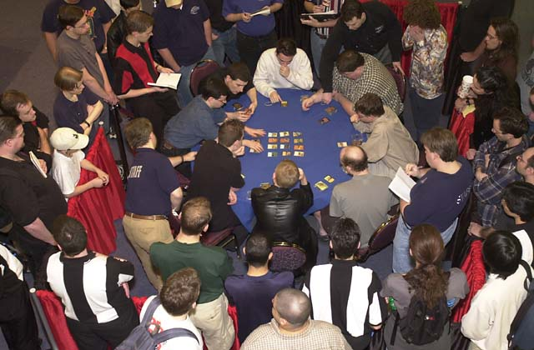
Creech: W/U/G
Gurney: B/R
Ekebom: B/U
Cornelissen: G/R/w
Pustilnik: U/W/b
Finkel: R/B
Klauser: G/W/r
Rose: B/R
That section of Alex's article is the closest thing to a summary of the entire draft. As the statistics show, this is a table that actually stuck to its colors rather well. Ekebom did so because his plan was to draft B/U at every table no matter what. The other three drafters that played only two colors played R/B. They also spent the whole draft fighting each other over a single color combination, and ended up without a match win other than Finkel's against Gurney. This brings to center stage the issues of the battle to stay in two colors and keep others in their two colors. A table that looks like it has a lot of two color mages can see that change in a hurry, and every early table is going to have two color mages branching out a few packs into the draft.
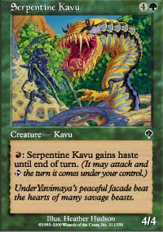
The worst part of that is that often the decision to add a color won't seem to make any sense whatsoever. That can totally wreck someone trying to balance the local situation at the table with the overall situation and still find something worth drafting. This is worst with green and certain nations of drafters. Apparently at LA there was a faction that believed in adding green to what was previously, say, a perfectly solid U/B deck without any in-draft or even in-pack reason to do so. The prime example of this that I observed in LA was in a practice draft on Thursday night. Faced with an array of solid picks, a U/B mage suddenly decided to take a Serpentine Kavu, between two other green mages. I couldn't process it; Why would anyone ever do that? Later it was explained that the player believed that G/u/b was the best deck in the format. Needless to say, I disagree.
Even with the highest level of player, the requirement of players to use allied colors can easily back players into a corner. The top eight draft is a great example of a seemingly solid choice of colors can turn into a disaster. The players at issue are the three R/B drafters: Gurney, Finkel and Rose. Obviously this isn't good for any of them, and by being in the finals they all demonstrated they know how to Rochester (even if two of them weren't Finkel and Rose). The most likely explanation without knowing how it happened is that two of them were locked in early on, and the third got sucked in somehow when it was too late for anyone to back out. Maybe one or more of them wanted to try for a third color but the cards just didn't come. Well, there's one way to find out for sure. Let's go to the actual draft picks, which for those who want to follow in depth can be found at www.wizards.com/sideboard/article.asp?x=PTLA01\822t8draftdetail
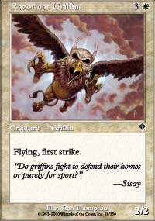
Creech started off the draft with a Razorfoot Griffin, after which Gurney took Cinder Shade. That's about as pure B/R as a pick can get. Finkel took Hooded Kavu over Lightning Dart four seats later, clearly indicating he wanted to go B/R as well. They were across the table from each other, so I'm sure this looked like more or less the ideal. If another player wanted to go in, not only would he be the third to draft the color combination but he'd be ill-placed, with at most seven packs out of the twenty-four where he was the first R/B player to draft a card. This is the essence of the strategy of drafting the same colors as the player directly across the table. It doesn't grant any edge over the competition, since the two players will split the picks evenly, but it does effectively shut out the other six players. This means in a Top 8 draft it also ensures the drafters' first round opponent equally good position but whoever gets through to the semifinals should be in good shape. Pustilnik and Creech did the same thing by splitting W/U in pack two, with Pustilnik taking Galena's Knight and Creech getting a Wings of Hope on the wheel. Both eventually went into third colors for unusual reasons later on, examples of Stealth Colors.
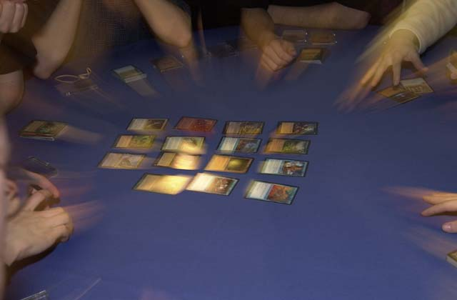
Pustilnik had two reasons. One was that he opened Stormscape Master in the fifth pack of the draft, whose black ability is excellent. The other is that Ekebom was the only B/U player at the table at the time. He picked up a Sleeper's Robe for free a few packs later since there were no playable alternatives, then on the way back he opened up Spite/Malice with no playable white or blue cards. Even if he played no Swamps it was probably the best card for his deck off just Spite! Well, second best behind Worldly Council but still. A little later he picked up a Ravenous Rats for free and a Probe that was clearly the best card for his deck whether he splashed black or not. At this point, Mike was probably looking at his cards wondering why things were going so wrong - he'd basically been forced into a real third color by the packs. It could have just been a splash, but with only one other B/U player it made sense to take full advantage of the Master. In case he was having second thoughts the only playable card for him two packs later was Voldalian Zombie. He was one of three blue mages! Why was this happening? It just was, no one was doing any counterdrafting or otherwise taking away his cards and all a good drafter can do in this kind of position is adjust.
After that, it just kept happening. He got Slinking Serpent twelfth. At this point, he had a few good white cards but his deck was closer to B/U without passing up any W/U cards in a very good W/U position. He took Benalish Trapper over Reckless Spite in the next pack, which was basically a concession to the quest for a good mana base. He's basically saying: The packs have not been kind to me. If I don't use the cards from all three colors, I don't have a good deck, so I'll try and salvage what cards I can and keep color requirements as small as possible. His decision was rewarded the next pack, where he got two first picks (Stormscape Apprentice and Shackles) on the wheel! After that, the last two packs had nothing at all he could use even with three solid colors. In the end, Mike was left using what he called 'Sealed Deck Mana' but with really high card quality. He drew his mana like he was born to, and it won him the Pro Tour.
What happened to Creech at the other side of the table? For the first set of packs, he stuck to W/U very well. In Pack 9 of the draft, a Charging Troll made it all the way around the table to him, and after deciding to take Crimson Acolyte, there was nothing else worth taking. This happened because the real W/G mages were kind of busy taking Armadillo Cloak and something called Rith, the Awakener. Then he got nothing good for the next three packs, which had few good cards and were sucked dry before he got his hands on anything. Pack 12 gave him a choice between Strength of Unity and Pincer Spider, and if he wasn't going to play the Pincer Spider then the Strength of Unity wasn't going to pump things all that much. Besides, at this point he's missing good cards from several consecutive packs and it's likely he'll end up having to splash in order to get a good deck. He also wasn't next to a green mage, and W/U/g has definite advantages. It's pretty clear he made the right call.
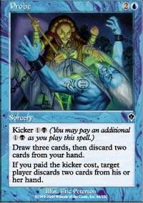
Pack 14 sealed the deal for him, with Verdeloth the Ancient going up against Probe. There was no chance Creech's deck would be able to play any Swamps (unless it quickly turned into 5CG, and that was highly unlikely) so he decided to abandon his quest for a good mana base as well and took the Ancient. In pack 17 he took Jade Leech over Glimmering Angel, making his green commitment even bigger. It's clearly no longer a splash color. The end of the draft brought him back to taking blue and white cards again for the most part. Only one of the packs gave him a choice, and he took Voldalian Serpent over Rooting Kavu. This almost certainly had more to do with his first round opponent playing Islands than anything else.
Next up are the cases of the R/B players. Gurney started with Cinder Shade and in the third pack picked up Plague Spores, so his plan was clear. By the end of pack four, it was clear that his position had deteriorated to the point where it was probably worth looking for a quick way out. The most likely out wasn't to abandon either color but to go seriously into a third one, the most likely being green. With only two clear green mages at the table and neither adjacent, that would be a good way to insure a good position. Some players like the combination more than others, but here it (or even straight R/G) was clearly what was called for.
Instead, the packs just didn't give him what he was looking for. The very next pack gave him a choice between Skittish Kavu and Recoil, and blue was clearly not a good choice for a third color in his position. In pack six he took a Fires of Yavimaya, clearly the beginning of an attempt to get where he wanted to be. The next pack never had anything green in it to begin with, and Gurney intentionally took Hate Weaver over Duskwalker to keep his black commitment as small as possible. Pack 8 continued to frustrate his intentions, as he took a Cursed Flesh because the only good green card was a Thornscape Apprentice and that's only really good with white. He picked up a Quirion Sentinel in pack 9, but that was the only green card available that didn't also require white. At this point, the Charging Troll he passed to Creech started pulling Creech into green as noted above, and that would end up taking Gurney's green cards away. He was in a great green position for several packs, and they conspired to give him only one playable green card in that time. By the time good green cards appeared, it was too late.
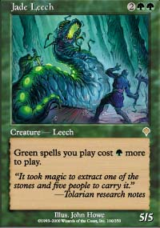
Or was it? There was definitely a turning point in this draft. A big case could be made that Pack 12 sealed Creech and Gurney's decks. Gurney basically had to choose between Zap and Pincer Spider. It was pretty clear that Creech had no alternative to the Spider if it got to him. If Gurney wants to go green badly enough, he takes the Pincer Spider both to have it and to keep it away. Creech already had a Charging Troll and his draft was clearly struggling. If the Pincer Spider goes to Gurney, Creech probably takes Recoil out of that pack rather than Explosive Growth - Gurney has just indicated he's going green so that's no longer something Creech wants that much. His next pack gives him Nomadic Elf instead of Mourning, and when Gurney takes Verdeloth away, Creech's pick is clearly Probe, leaving his first round opponent Mike Pustilnik with no pick from that pack. Pack 16 rewards Gurney with a free Kavu Climber, Creech takes Glimmering Angel or Obsidian Acolyte over what is now Gurney's Jade Leech. He probably also gets a Rooting Kavu later on.
Would this alternate deck have been better? Its mana is clearly worse. Gurney is now the one with the 'sealed deck mana.' The packs would actually not have been particularly kind to Gurney (though not terribly cruel) if he'd gone in this direction with his draft, refusing to give him good green mana sources or spells without double green in their casting cost. He gets the Nomadic Elf, one Fertile Ground for free, but would have to pay an extreme price to do better than that. It's a drastic change of deck type, since what he had before was designed to be quick consistent beatdown and what he has now is much less consistent and much slower, but with higher card quality. I think if the Kavu Scout, Quirion Sentinel and Fires of Yavimaya he already had were added in and he gives up the now unneeded although better Firebrand Rangers, the deck he ends up drafting is probably a little better than what he ended up with.
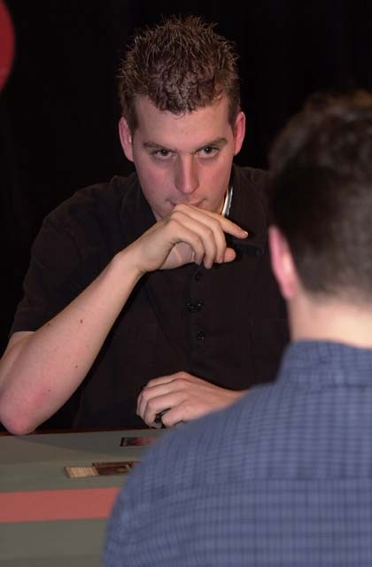
What would have happened to everyone else's deck? Jon Finkel and Kyle Rose get better decks as Gurney passes them many more R/B cards than before. Creech gets a W/U/b deck instead of being W/U/G, getting removal instead of big creatures for his trouble. His creature base is now less than ideal, but his removal is much better. Mike Pustilnik's deck, by contrast, becomes slightly weaker due to Creech taking a few of his cards away, and Creech gets a much better chance in what is probably still a bad matchup. Finkel still has an edge on Gurney but not as big an edge as before. Cornelissen's deck takes a small hit and Rose's gets significantly better, so Rose gets a better shot although he's still an underdog. Klauser has a bigger edge than before over Ekebom. If he draws his mana the way he did, Mike is still the clear favorite to win it all.
The next place to focus in is on Kyle Rose. Here we have a case of the tragic Deck That Never Came, which is what happened to me in my first LA draft. Kyle's position was pretty clearly B/U, as incidentally was mine (and we were both in seat eight). The first pack simply left him nothing worth taking on the wheel. The second pack gave him some useful black cards, but the only good blue card he could have taken was Stand/Deliver, and he decided to let Creech have that to get two good black cards. Pack three is interesting, giving him a choice between Shivan Emissary and Sky Weaver. This decision will basically decide how the entire draft will go. If he takes the Sky Weaver, he's clearly on the road to U/B. If he takes the Emissary, he's going for R/B or maybe R/B/u. He took Nightscape Apprentice out of the next pack, with the blue alternative being Shoreline Raider. In the next pack he took Backlash over what would have been Recoil. This pick makes it clear: He's not trying for a three color deck. He's going straight for pure R/B.
This decision would not have sent as many ripples through the rest of the draft as the others. Basically Rose takes a bunch of blue cards away. Again Mike Pustilnik's deck takes a hit, ending up weaker if with slightly better mana. Creech's deck suffers somewhat, but not seriously, and Ekebom's takes a bigger hit. As usual the other two B/R decks improve. Rose's chances definitely improve.
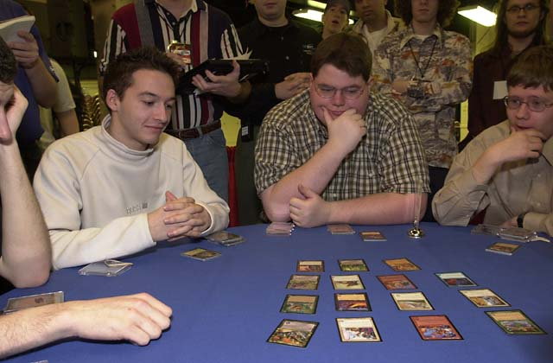
Do I disagree with what Kyle Rose did in the Top 8 draft? Yes, I'm pretty sure I would have traveled down the other path. Would he be the Pro Tour champion right now if he had? Highly unlikely. His deck is poor either way. The Riths he opened were never his, and the only way he possibly ends up with them is if he knows they're coming. Even then it doesn't make all that much sense. While I disagree with Rose's decision, he made it to the Top 8 while I scrubbed out, so I definitely have to give him the benefit of the doubt. It's certainly a legitimate decision to go the way he did.
Then there's Finkel. By the time Rose indicated which way he would go, Finkel already had a Pyre Zombie. Early in the draft he clearly had no outs, and he had the best position of the three R/B drafters. Later on, he faces more or less the same opportunities to go into B/U as everyone else. In packs eleven and twelve he picked up Repulse and Recoil, seemingly ready to go into a third color. But two packs later, he's taking Zap over Probe, and that sealed the deal. In his case, I agree with his decision to stay in two colors, but he was understandably upset with the other drafters. One Probe, three opportunities, one late pick find and one Pro Tour champion. That's the story of Los Angeles.

